1. In last lecture, we started up a copy of redis server inside a running container.
2. **Agenda**: Now we have to figure out how to start up the redis CLI also inside of that container.
3. For this, we will use another docker command.
4. 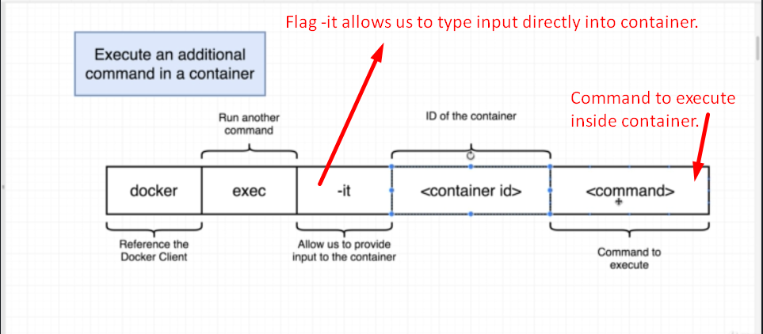
5. –it: This flag allows us to enter in text on our keyboard and have it be sent into that running container.  
   If without –it flag, you issue the command 🡺 docker exec <image_id>
6. Let’s start a second program inside the container by executing the command  
   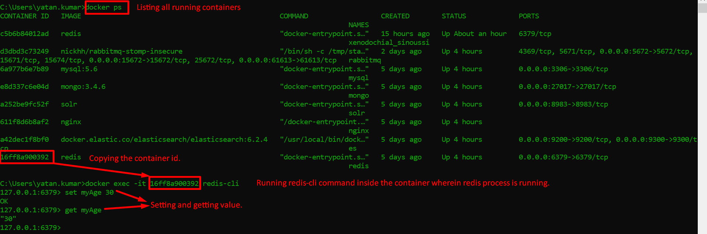
7. 